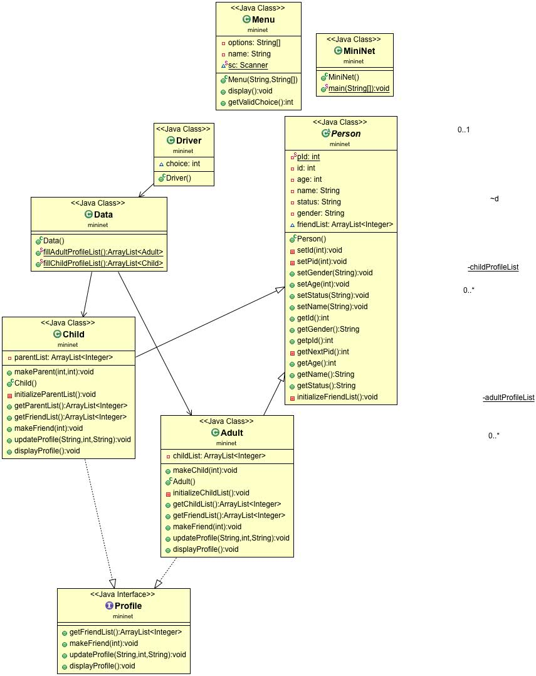

**How the design will be able to store the profile information?**

The program will utilize two array lists to store information of the profiles. The first array list is used to store information for Persons who are older than 16 years, and the second array list is used to store the information for the children who are younger than 16 years. These two arrays are declared and used in Driver class. The demo data sorted in data class.

**How the class hierarchy will facilitate the network management?**

There is an interface used in the program named Profile, having all methods which the Person and Child classed have to implement. The Person and Child class also extends from Person class. The Person class is an abstract class and has all private data members and the public methods. The Person and Child classes have their own data members and methods. This hierarchy will facilitate the network management.

**Process by which your program can maintain the networks and find connections more efficiently**

The main program will start with a main menu, from where the user can select an option. In the main class, some hard coded data is loaded in to two Array lists that is sorted in Menu class. The program has 3 main menu, and other options are available as sub menu of these main menu. All requirements are kept in while writing codes for the program. The program uses two arrays to store the profiles, one for Adult type profile, and second for Child type profile. The new profiles will also be added to one of these array (according to the type of profile). The program uses a menu to get the inputs from user and show the choices according to the user choice. When the user wants to show all profiles, the program will loop through the array of the profiles and will display the information about all profiles. Adding a person, select first option from main menu, then choose if you want to add an Adult or Child person. The program will take necessary inputs from user, validate the inputs and will add that profile to list of profiles. To select a single profile, user has to enter the partial or full name of the profile and if the profile exists, the program will display the options to

* View that profile
* Update profile
* Delete profile
* Add a profile to this profile as a friend
* Display all friends of the selected profile
* Display Children or parents of selected profile
* Checking for friendship with another profile.